**Experiment - 5**

**Aim:**

**Write programs for studying Usage of arithmetic operators in Prolog.**

**Procedure:-**

**Write program to-**

1. Accept name of the student, roll no, his subject name, maximum marks and obtained marks in the subject. (Take marks of at least 6 subjects). Compute the percentage of a student. Display his result with other information.

* Use variables, arithmetic operators, I/O predicates appropriately.

Prolog Code:

domains

name,dept,sub=symbol

predicates

start

result(real,real,real,real,real,real,real,real,real,real)

clauses

start:-nl,

write("**************************************"),nl,

write("Enter Student Name : "),readln(A),

write("Enter Roll number : "),readln(B),

write("Enter subject information for 5 subjects :-"),nl,

write("Subject Name : "),readln(S1),

write("Max marks-"),readreal(M1),

write("Obtained marks-"),readreal(O1),

write("Subject Name : "),readln(S2),

write("Max marks-"),readreal(M2),

write("Obtained marks-"),readreal(O2),

write("Subject Name : "),readln(S3),

write("Max marks-"),readreal(M3),

write("Obtained marks-"),readreal(O3),

write("Subject Name : "),readln(S4),

write("Max marks-"),readreal(M4),

write("Obtained marks-"),readreal(O4),

write("Subject Name : "),readln(S5),

write("Max marks-"),readreal(M5),

write("Obtained marks-"),readreal(O5),nl,

write("****************RESULT****************"),nl,

write("Student Name: ",A),nl,

write("Roll number: ",B),nl,

write("Subjects: '",S1,"','",S2,"','",S3,"','",S4,"','",S5,"'."),nl,

result(M1,M2,M3,M4,M5,O1,O2,O3,O4,O5).

result(M1,M2,M3,M4,M5,O1,O2,O3,O4,O5):-

M=M1+M2+M3+M4+M5,

write("Total Maximum Marks: ",M),nl,

O=O1+O2+O3+O4+O5,

write("Total Obtained Marks: ",O),nl,

P=(O*100)/M,

writef("Percentage: %0.2f",P),nl,

write("**************************************"),nl,nl,

write("do you want to continue(y/n) ? "),

readln(Z),

Z="y",

start.

Output Screenshots:

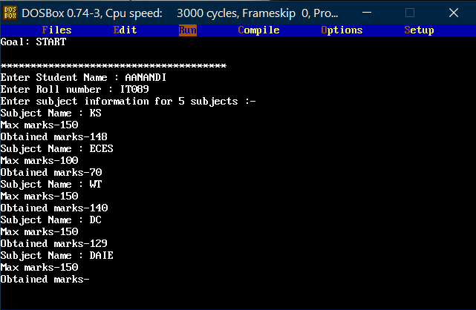

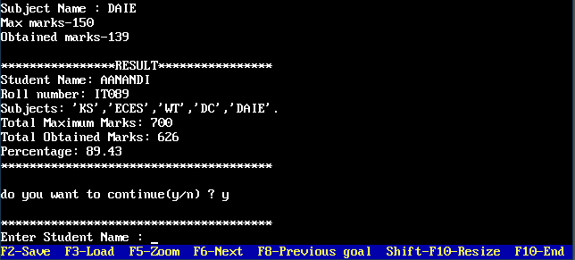

1. Accept department, designation, name, age, basic salary, house rent allowance (HRA) of an employee. Compute dearness allowance (DA) which is 15% of basic salary. Determine the gross salary (basic salary+HRA+DA) of the employee. Display all information of the employee.

* Use variables, rules, I/O predicates, arithmetic operators as per needed.

Prolog Code:

domains

name,dept=symbol

predicates

start

empinfo(symbol,symbol,integer,real,real)

dallowance(real)

gsalary(real,real)

clauses

start:-nl,

write("*******************************"),nl,

write("Enter Employee Name : "),readln(A),

write("Enter Department : "),readln(B),

write("Enter Age : "),readint(C),

write("Enter HRA : "),readreal(H),

write("Enter Basic Salary : "),readreal(S),

empinfo(A,B,C,S,H).

empinfo(A,B,C,S,H):-nl,

write("************PAYSLIP************"),nl,

write("Employee Details:-"),nl,

write("Name : ",A),nl,

write("Department : ",B),nl,

write("Age : ",C),nl,

write("BA : ",S),nl,

dallowance(S),

write("HRA : ",H),nl,

gsalary(S,H),

write("*******************************"),nl,

write("do you want to continue(y/n) ? "),

readln(Z),

Z="y",

start.

dallowance(S):-

D=S*0.15,write("DA : ",D),nl.

gsalary(S,H):-

G=S+H+(0.15*S),

write("GS : ",G),nl.

Output Screenshots:

